**Sprint Plan 1 - CSE 115-A – Intro to Software Engineering**

∙ **Heading:** Document name ("Sprint {number} Plan"), product name, team name, sprint completion date, revision number & revision date.

∙ **Goal:** Short, 1-2 sentence description of the high-level goal(s) for the sprint.

Create a UI capable of displaying current dining hall meals…

∙ **Task listing, organized by user story:** This section lists the user stories, in priority order from most important (top) to least important (bottom). Within each user story, there needs to be a list of tasks required to implement the user story, along with the time estimate for each tasks (preferably less than or equal to 6 ideal hours). This should look like:

* User Story 1: As a UCSC student who eats at the dining hall, I want to be able see all the dining hall options on a webpage.
* User Story 2: As a UCSC student who eats at the dining hall, I want to be able to navigate to each dining hall’s page and view the current day’s menu.
* User Story 3: As a UCSC student who eats at the dining hall, I want to be able to see the nutritional information of each meal in the dining hall.

∙ **Team roles:** Give a listing of all team members. Next to the team member, list their role(s) for this sprint. Assign each person to at least one role (for example, this role might be "Developer"). This looks like:

Aiden: Frontend Developer

*Violet : Help create UI & integrate the web scraper to the front end - Full stack developer*

Artem: Full stack developer

Amish: Creating web scraper and daily scheduler

Kevin: Database creation and storage

*Team member 1: role 1 {, role 2, role 3}*

∙ **Initial task assignment:** A listing of each team member, with their first user story and task assignment. This should look like:

Violet : User story 1, helping develop UI & connecting web scraper to front end

Aiden: User story 1, Creating profile and menu UI (Colab with artem)

Artem: User story 1, Creating the profile and menu UI

∙ **Initial burnup chart:** A graph giving the initial burnup chart for this sprint and is labeled as such with sprint number and project name and is located in the lab.

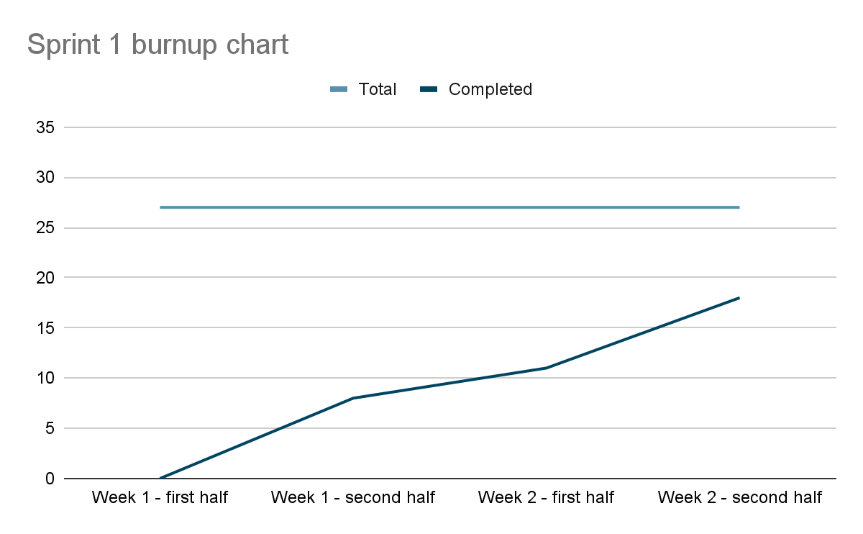

∙ **Initial scrum board:** Also known as a task board, the scrum board is a physical board and labeled as such with sprint number and project name and located in the lab. This board has four columns, titled user stories, tasks not started, tasks in progress, and tasks completed. Index cards or post-it notes representing the user stories and the tasks for this sprint should be placed in the user stories, tasks not started, and tasks in progress columns. Tasks associated with a user story should be placed in the same row as the user story.

∙ **Scrum times:** List at least the three days and times during the week when your team will meet and conduct Scrum meetings. Also, indicate which of these meetings will have the TA/tutor visit as arranged with the TA/tutor. It is expected the TA/tutor will visit during the Scrum meeting during your lab time.

Note that if the team ended up modifying its release plan during sprint planning, submit an updated release plan document also with the sprint plan.

Last modified: 10/15/13 adapted from materials for cmps171